EXPERIMENT- 2
Q] Write a python program for 8-Queen problem.
Aim-
To solve the 8-Queens Problem using the Backtracking Algorithm, such that no two queens attack each other.
Algorithm-
- Start from the first row.
- Place a queen in each column one by one.
- Check whether the position is safe.
- If safe, place the queen and move to the next row.
- If no safe position is found, backtrack to the previous row and move the queen to the next column.
- Repeat until all 8 queens are placed successfully.
- Display the chessboard with the queen positions.
Program-
N = 8
board = [[0 for _ in range(N)] for _ in range(N)]
def isSafe(board, row, col):
for i in range(col):
if board[row][i] == 1:
return False
i = row
j = col
while i >= 0 and j >= 0:
if board[i][j] == 1:
return False
i -= 1
j -= 1
i = row
j = col
while i < N and j >= 0:
if board[i][j] == 1:
return False
i += 1
j -= 1
return True
def solve(board, col):
if col >= N:
return True
for row in range(N):
if isSafe(board, row, col):
board[row][col] = 1
if solve(board, col + 1):
return True
board[row][col] = 0
return False
if solve(board, 0):
print("Solution Found:\n")
for row in board:
print(row)

else:
print("No Solution Exists")
Sample Input-
Number of Queens = 8
Sample Output-
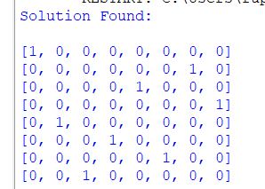

Result-
The 8-Queens Problem was solved successfully using the Backtracking Algorithm, and a valid arrangement of 8 queens on the chessboard was obtained such that no two queens attack each other.

